Civil war in Sierra Leone

UNSC Resolution: | 1306
Date of adoption: | 5 July 2000
Operative paragraph: | 2
Demand number: | 1

Megan MacKenzie

Wording of demand
ensure, as a matter of urgency, that an effective Certificate of Origin regime for trade in diamonds is in operation in Sierra Leone

List of addressees of the demand
Government of Sierra Leone

Short-term compliance

Description of the addressee(s)’ conduct

On 5 July 2000, UN Security Council Resolution 1306 prohibited the import of diamonds from Sierra Leone. The Ministry of Mineral Resources then created a licensing and certification regime to enable Sierra Leone to export diamonds legally again. Since October 2000, the government has had an exemption from Resolution 1306 to export diamonds through this regime.216. p26

On July 31 and August 1, 2000, at informal UN hearings in New York, the GOSL
presented the basic elements of a new mining and export regime, which it hoped would qualify for an exemption to UN Resolution 1306 (2000). In mid October, the major elements of the new export regime were operational, and the Security Council granted the GOSL an exemption to Resolution 1306, to permit exports to resume.

Assessment

Short-term compliance
No or marginal compliance (1) | Medium low compliance (2) | Medium high compliance (3) | x Full or almost full compliance (4)

Considerations underlying the assessment
It is clear that the Government of Sierra Leone responded directly to this demand by creating a certificate of origin scheme. The UN recognized their efforts and permitted them to resume exports during this short term period.

Medium-term compliance

Description of the addressee(s)’ conduct
On July 31 and August 1, 2000, at informal UN hearings in New York, the GOSL
presented the basic elements of a new mining and export regime, which it hoped would qualify for an exemption to UN Resolution 1306 (2000). In mid October, the major elements of the new export regime were operational, and the Security Council granted the GOSL an exemption to Resolution 1306, to permit exports to resume.

August 2003, President Kabbah launched the Kono Peace Diamond Alliance, the goals of which, he said,were to eradicate unfair practices in Sierra Leone’s diamond industry and curb the financing of terrorism,while ensuring legality and profitability.p25

Assessment

Medium-term compliance
No or marginal compliance (1) | Medium low compliance (2) | Medium high compliance (3) | x Full or almost full compliance (4)

Considerations underlying the assessment
This demand was met within six months. As a result, there is no a great need for further research as to the long term compliance with the demand.

Depth of demand

Assessment

Level of depth of demand
x Low depth of demand (1) | Medium depth of demand (2) | High depth of demand (3)

Considerations underlying the assessment
It was in the interest of the Government of Sierra Leone to meet this demand because limitations had been put on their ability to sell diamonds in the global market. Complying with this demand allowed them to resume selling diamonds, which were a major source of income for the country.

Level of confidence about coding decisions

Level of confidence about coding decision
x Extremely high | High | Moderate

Comments to IPI (if any)

Civil war in Sierra Leone

UNSC Resolution: | 1306
Date of adoption: | 5 July 2000
Operative paragraph: | 4
Demand number: | 1

Megan MacKenzie

Wording of demand

notify the Committee established by resolution 1132 (1997) ("the Committee") of the details of such a Certificate of Origin regime when it is fully in operation

List of addressees of the demand

Government of Sierra Leone

Short-term compliance

Description of the addressee(s)’ conduct

On July 31 and August 1, 2000, at informal UN hearings in New York, the GOSL
presented the basic elements of a new mining and export regime, which it hoped would qualify for an exemption to UN Resolution 1306 (2000). In mid October, the major elements of the new export regime were operational, and the Security Council granted the GOSL an exemption to Resolution 1306, to permit exports to resume.

Assessment

Short-term compliance
No or marginal compliance (1) | Medium low compliance (2) | Medium high compliance (3) | x Full or almost full compliance (4)

Considerations underlying the assessment

It is clear that the Government of Sierra Leone notified the Committee established by resolution 1132 at informal hearings in New York. As a result, the Government was allowed to resume selling diamonds.

Medium-term compliance

Description of the addressee(s)’ conduct
On July 31 and August 1, 2000, at informal UN hearings in New York, the GOSL
presented the basic elements of a new mining and export regime, which it hoped would qualify for an exemption to UN Resolution 1306 (2000). In mid October, the major elements of the new export regime were operational, and the Security Council granted.
the GOSL an exemption to Resolution 1306, to permit exports to resume.

Assessment

Medium-term compliance
No or marginal compliance (1) | Medium low compliance (2) | Medium high compliance (3) | x Full or almost full compliance (4)

Considerations underlying the assessment

The Government of Sierra Leone complied with this demand within six months of it being issued.

Depth of demand

Assessment

Level of depth of demand
x Low depth of demand (1) | Medium depth of demand (2) | High depth of demand (3)

Considerations underlying the assessment
It was in the interest of the Government of Sierra Leone to meet this demand because limitations had been put on their ability to sell diamonds in the global market. Notifying the committee of the certificate of origin scheme did not put any pressure on the Government, in fact complying with the demand permitted them to resume selling diamonds, which were a major source of income for the country.

Level of confidence about coding decisions

Level of confidence about coding decision
x Extremely high | High | Moderate

Comments to IPI (if any)

Civil war in Sierra Leone

UNSC Resolution: | 1306
Date of adoption: | 5 July 2000
Operative paragraph: | 14
Demand number: | 1

Megan MacKenzie

Wording of demand

extension of government authority to the diamond-producing areas for a durable solution to the problem of illegal exploitation of diamonds in Sierra Leone

List of addressees of the demand

Government of Sierra Leone

Short-term compliance

Description of the addressee(s)’ conduct
On 5 July 2000, UN Security Council Resolution 1306 prohibited the import of diamonds from Sierra Leone. The Ministry of Mineral Resources then created a licensing and certification regime to enable Sierra Leone to export diamonds legally again. Since October 2000, the government has had an exemption from Resolution 1306 to export diamonds through this regime.216 These measures, in conjunction with the end of the war and the return of the diamond areas to government control, have begun to increase legal exports and reduce the trafficking of illicit diamonds but they have not solved the
dilemma of controlling illicit mining and smuggling. While officials believe smuggling
has been significantly reduced, most donors believe it is still a major problem and the
government has not done enough. p26

Assessment

Short-term compliance
No or marginal compliance (1) | Medium low compliance (2) | x Medium high compliance (3) | Full or almost full compliance (4)

Considerations underlying the assessment
This report shows that the Government of Sierra Leone were successful in extending their authority within the diamond producing regions; however, it indicates that there remained some concern about illegal diamond sales and smuggling.

Medium-term compliance

Description of the addressee(s)’ conduct

P5 While UNASMIL has been pulling out as planned, concerns have grown that the government will not meet the benchmarks, especially on police and
diamond mining. p5

3. The joint committee on disarmament, demobilization and reintegration comprising
UNAMSIL, the Government of Sierra Leone and RUF held two meetings during the reporting period, the first in Bo on 17 July and the second in Kenema on 10 August. At the meeting in Bo it was agreed that, after the completion of the disarmament exercise in Kambia
and Port Loko districts, the disarmament, demobilization and reintegration programme would
begin in Kono and Bonthe districts in July, after which the exercise would be conducted in the following
order: Koinadugu and Moyamba districts, Bombali and
Bo, Tonkolili and Pujehun, and Kailahun and Kenema
districts. The parties also agreed on a moratorium on
diamond mining in order to facilitate the disarmament
process in Kono district. Although the agreement on
the moratorium is believed to have facilitated disarmament in that district, the parties have not been able to enforce the moratorium and illegal mining activities have continued.
29. The deployment of the Sierra Leone police in Kono district is now being prepared with the assistance of UNAMSIL. This is an important task and will constitute a substantial challenge, given the lack of infrastructure and more importantly the need to regulate diamond-mining activities. UNAMSIL continues to encourage the Government to develop a comprehensive plan for the management of the diamond mines. The Government is currently reviewing various options for the management of mining concessions.

Assessment

Medium-term compliance
No or marginal compliance (1) | x Medium low compliance (2) | Medium high compliance (3) | Full or almost full compliance (4)

Considerations underlying the assessment
It is clear that the Government of Sierra Leone was making efforts to extend its authority and monitor the illegal exploitation of diamonds, there is indication that they did not have full control over the diamond regions and that smuggling and the illegal sale of diamonds was still happening.

Depth of demand

Assessment

Level of depth of demand
Low depth of demand (1) | x Medium depth of demand (2) | High depth of demand (3)

Considerations underlying the assessment
Although it was in the interests of the Government of Sierra Leone to comply with this demand, it required attaining control over a region the RUF had maintained control over for a long period of time. The diamond producing areas had also been wrought with hostilities. As a result, complying with this demand required removing the RUF from their power over this region.

Level of confidence about coding decisions

Level of confidence about coding decision
Extremely high | x High | Moderate

Comments to IPI (if any)

Civil war in Sierra Leone

UNSC Resolution: | 1334
Date of adoption: | 22 December 2000
Operative paragraph: | 2
Demand number: | 1

Megan MacKenzie

Wording of demand

give a more convincing demonstration of commitment to the peace process

List of addressees of the demand
Revolutionary United Front

Short-term compliance

Description of the addressee(s)’ conduct
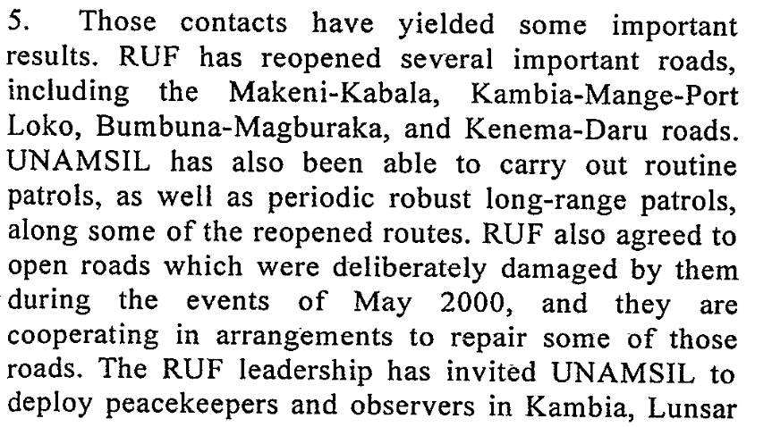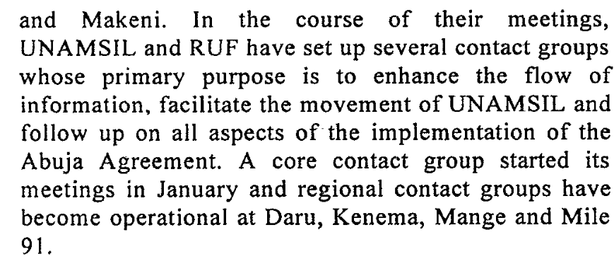
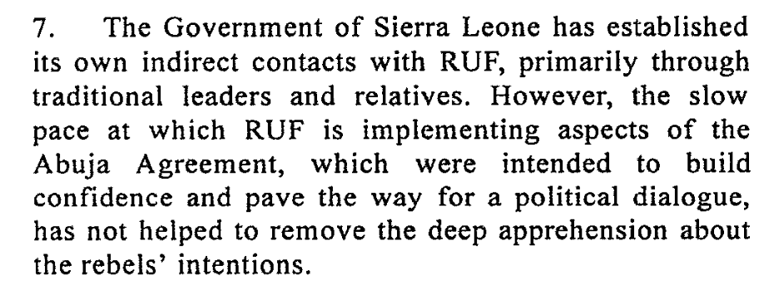14 March 2001

Assessment

Short-term compliance
No or marginal compliance (1) | x Medium low compliance (2) | Medium high compliance (3) | Full or almost full compliance (4)

Considerations underlying the assessment
The RUF showed some signs of complying with this demand. They changed some of their behaviors and were involved in talks with the Government of Sierra Leone.

Medium-term compliance

Description of the addressee(s)’ conduct
2. The Sierra Leone peace process continued to make encouraging progress during the period under review. The disarmament of combatants of the Revolutionary United Front (RUF) and the Civil Defence Forces (CDF) has so far been completed in four districts, including the diamond-producing Kono district. With the exception of skirmishes between the Civil Defence Forces and RUF which marred the initial stages of the disarmament exercise in Kono district, the ceasefire has generally continued to hold.
3. The joint committee on disarmament, demobilization and reintegration comprising
UNAMSIL, the Government of Sierra Leone and RUF held two meetings during the reporting period, the first in Bo on 17 July and the second in Kenema on 10 August.
4. At the meeting held in the town of Bo on 17 July, RUF requested the Government to facilitate its registration as a political party and to release some of the RUF officials detained during the crisis of May 2000.
6. The Government and RUF have also taken additional reciprocal confidence-building measures,including the continuing release of abductees and child combatants by RUF, the participation by both sides in joint sensitization and reconciliation campaigns, the
enrolment of some RUF ex-combatants in the military reintegration programme, the renewal of the provisional registration of the RUF Party by the National Electoral Commission and an invitation to the party to participate in discussions on the electoral process. 7 September 2001

Assessment

Medium-term compliance
No or marginal compliance (1) | Medium low compliance (2) | x Medium high compliance (3) | Full or almost full compliance (4)

Considerations underlying the assessment
Although this period was still characterized by violence and human rights abuses, the resolution asks for a more convincing demonstration of commitment to the peace process. As such, there are several indicators that the RUF were committed to the peace process and were changing their behaviors.

Depth of demand

Assessment

Level of depth of demand
Low depth of demand (1) | x Medium depth of demand (2) | High depth of demand (3)

Considerations underlying the assessment
This is a medium depth demand because it does asks the party to show commitment to the peace process but does not give specific indications of what actions the party should take or what time frame the party should act within. As such, even though the party continued to precipitate violence and human rights abuses, they also showed some commitment to the peace process.

Level of confidence about coding decisions

Level of confidence about coding decision
Extremely high | x High | Moderate

Comments to IPI (if any)

Civil war in Sierra Leone

UNSC Resolution: | 1346
Date of adoption: | 30 March 2001
Operative paragraph: | 6
Demand number: | 1

Megan MacKenzie

Wording of demand
cease acts immediately [human rights abuses, forced recruitment of children]

List of addressees of the demand

Revolutionary United Front, Civil Defence Forces

Short-term compliance

Description of the addressee(s)’ conduct
25 June 2001
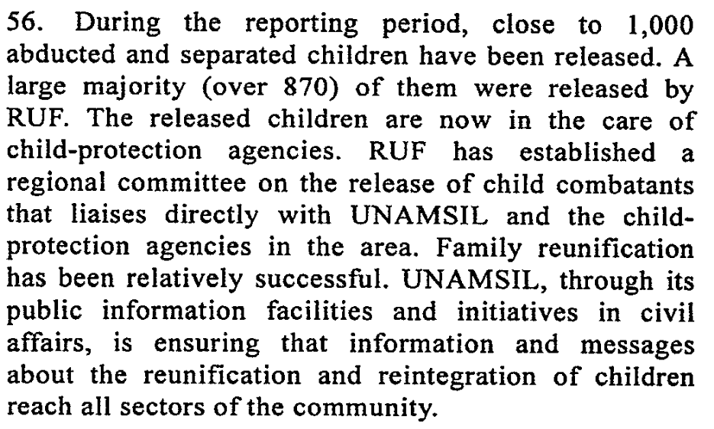
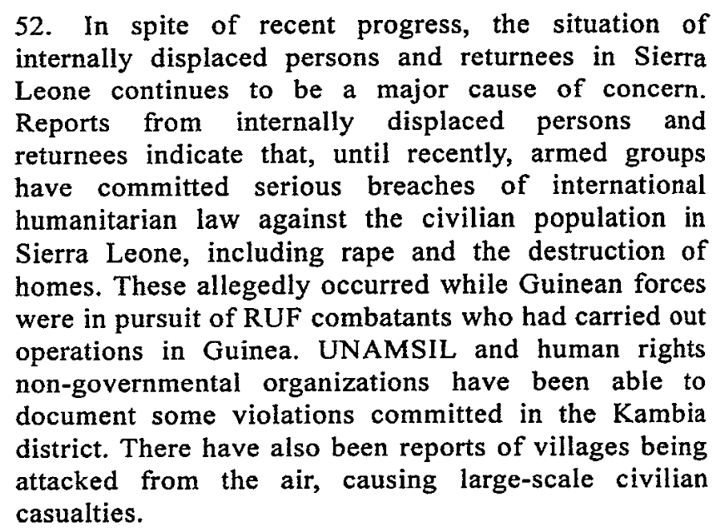

Assessment

Short-term compliance
x No or marginal compliance (1) | Medium low compliance (2) | Medium high compliance (3) | Full or almost full compliance (4)

Considerations underlying the assessment
The RUF made an effort to respond to concerns regarding child soldiers but they also were accused of continued human rights abuses during this period.

Medium-term compliance

Description of the addressee(s)’ conduct
43. Child combatants, abductees and other separated children continued to be released to UNAMSIL by RUF. From May to 31 July, 1,169 children were released in Makeni, Kailahun and Tongo. A total of 1,214 children have been demobilized by RUF and 646 children by the Civil Defence Forces.

40. Investigations conducted by the Human Rights Section of UNAMSIL during the reporting period revealed attacks against the civilian population by both RUF and the Civil Defence Forces in several villages in the Kono and Koinadugu districts. On 17 June 2001, a CDF group attacked the village of Yaraiya. Corroborating witness accounts revealed that 24 people
were killed in the attack. Following that incident, RUF combatants attacked the village of Henekuma on 19 July, killing at least 19 people. 7 September 2001

Assessment

Medium-term compliance
x No or marginal compliance (1) | Medium low compliance (2) | Medium high compliance (3) | Full or almost full compliance (4)

Considerations underlying the assessment
The RUF showed some indication that they were aware of concerns regarding child soldiers. Both the RUF and the CDF were accused of continued human rights abuses during this period.

Depth of demand

Assessment

Level of depth of demand
Low depth of demand (1) | x Medium depth of demand (2) | High depth of demand (3)

Considerations underlying the assessment
The RUF and the CDF had relied on child soldiers. In addition, both of these parties were accused of human rights abuses and the RUF in particular had used human rights abuses to terrorize populations and attain power. As such, complying with this demand required the parties to alter their behaviors drastically.

Level of confidence about coding decisions

Level of confidence about coding decision
Extremely high | x High | Moderate

Comments to IPI (if any)

Civil war in Sierra Leone

UNSC Resolution: | 1346
Date of adoption: | 30 March 2001
Operative paragraph: | 7
Demand number: | 1

Megan MacKenzie

Wording of demand
take immediate steps to fulfill its commitments under that Agreement to ensure full liberty for the United Nations to deploy its troops throughout the country, the free movement of persons and goods, unimpeded movement of humanitarian agencies, refugees and displaced persons and the immediate return of all seized weapons, ammunition and other equipment, and to recommence active participation in the disarmament, demobilization and reintegration programme

List of addressees of the demand

Revolutionary United Front

Short-term compliance

Description of the addressee(s)’ conduct

Of course, no disarmament process can expect to get all the weapons, but the process in Sierra Leone has been particularly poor, and few observers doubt that RUF commanders are holding back caches. On the surface, significant strides appear to have been made in the disarmament process. About 22,000 combatants have disarmed since the DDR program resumed in May 2001, over a third of the estimated total. P4

May 2001 the Government of Sierra Leone and RUF met in Abuja for Abuja II and agreed to recruit demobilized RUF personnel into national army and police. RUF pledged to return the weapons and equipment it had seized from UNAMSIL and ECOMOG and to disarm simultaneously with the CDF. RUF dropped its demand that the SLA be included in the DDR program. Gov and RUF agreed to dismantle all roadblocks in their respective areas.

Assessment

Short-term compliance
No or marginal compliance (1) | Medium low compliance (2) | x Medium high compliance (3) | Full or almost full compliance (4)

Considerations underlying the assessment
This is a very specific and detailed demand. The RUF showed signs that it was taking steps to fulfill its commitments under the Agreement and to ensure full liberty for the United Nations to deploy its troops throughout the country.

Medium-term compliance

Description of the addressee(s)’ conduct
Ultimately, as soon as fighting resumed, recently disarmed soldiers broke open the weapons depots, rearmed themselves, and returned to the bush. (1999)

RUF’s response in Kambia was overwhelming, and the quality of weapons turned over at the reception center was high. Turnout at the Port Loko site was quite low….By the end of Oct 2001, the pace of the program had increased to meet its goal of completion before the May 2002 elections.

Assessment

Medium-term compliance
No or marginal compliance (1) | Medium low compliance (2) | x Medium high compliance (3) | Full or almost full compliance (4)

Considerations underlying the assessment

During this extended period of time the RUF showed strong signs of commitment to the Agreement- particularly with regard to disarming and ceasing hostilities.

Depth of demand

Assessment

Level of depth of demand
Low depth of demand (1) | Medium depth of demand (2) | x High depth of demand (3)

Considerations underlying the assessment
For the RUF, fully complying with the Peace Agreement meant relinquishing power as well as altering their behavior and structure drastically.

Level of confidence about coding decisions

Level of confidence about coding decision
Extremely high | High | x Moderate

Comments to IPI (if any)

Civil war in Sierra Leone

UNSC Resolution: | 1346
Date of adoption: | 30 March 2001
Operative paragraph: | 10
Demand number: | 1

Megan MacKenzie

Wording of demand
intensify their efforts towards the full and peaceful implementation of the Abuja Ceasefire Agreement and the resumption of the peace process, taking into account the basis of the Abuja Ceasefire Agreement and relevant Security Council resolutions

List of addressees of the demand

Government of Sierra Leone, Sierra Leone Army, Civil Defence Forces , Revolutionary United Front

Short-term compliance

Description of the addressee(s)’ conduct

The meeting (Abuja II) saw the rebel group give new life to the peace process when it dropped its demand that the Sierra Leone Army (SLA) disarm, and agreed to return to the disarmament process which had stalled with the failure of the Lomé peace process in May 2000.p1 Since the signing of Abuja II, over 22,000 RUF and CDF combatants have entered the Disarmament, Demobilisation, Reintegration (DDR) process, almost one half of the estimated
total of 45,000 combatants in the country. The cease-fire has also held since May, though with the notable exception of RUF-CDF skirmishes in the diamond-producing Kono district in the east. P1 May 2001 the Government of Sierra Leone and RUF met in Abuja for Abuja II and agreed to recruit demobilized RUF personnel into national army and police. RUF pledged to return the weapons and equipment it had seized from UNAMSIL and ECOMOG and to disarm simultaneously with the CDF. RUF dropped its demand that the SLA be included in the DDR program. Gov and RUF agreed to dismantle all roadblocks in their respective areas.
Two weeks after Auja II [May 2001] representatives from UNAMSIL, gov, CDF, RUF met in Freetown –first high level meeting of all these parties since may 2000.

Assessment

Short-term compliance
No or marginal compliance (1) | Medium low compliance (2) | Medium high compliance (3) | x Full or almost full compliance (4)

Considerations underlying the assessment
This was a complicated and multifaceted demand. The parties made a marked effort to intensify their efforts towards the implementation of the Agreement and the peace process was resumed within this time frame.

Medium-term compliance

Description of the addressee(s)’ conduct
In November [20000 a cease-fire was agreed in Abuja between the RUF and the
government, which was followed by a break in fighting. However, the RUF
continues to commit atrocities against the civilian population and to block UN
deployment. Furthermore, the fighting has spread to Guinea, where the RUF is
backing rebels. P13

On 13 January 2003, a small group of former soldiers and civilians attacked an RSLAF armoury at Wellington, five miles outside Freetown. P6 Since January 2002 when President Ahmed Tejan Kabbah officially declared Sierra Leone’s brutal eleven year civil war over, numerous efforts have been made to consolidate the peace. The 14 May election in which the Revolutionary United Front (RUF) rebel group participated and was politically defeated, was, even if flawed, a significant step forward. p1

Assessment

Medium-term compliance
No or marginal compliance (1) | Medium low compliance (2) | Medium high compliance (3) | x Full or almost full compliance (4)

Considerations underlying the assessment
Within this longer period of time the war came to an official end. There were still some indications of violence and human rights abuses but the demand specifies that the parties should “intensify their efforts towards the full and peaceful implementation of the Abuja Ceasefire Agreement” and it does appear that despite some violations, this demand was met.

Depth of demand

Assessment

Level of depth of demand
Low depth of demand (1) | x Medium depth of demand (2) | High depth of demand (3)

Considerations underlying the assessment
Because the demand asks parties to intensify their efforts rather than cease all acts immediately, it places less restriction both in terms of behavior and in terms of a time frame.

Level of confidence about coding decisions

Level of confidence about coding decision
Extremely high | High | x Moderate

Comments to IPI (if any)

Civil war in Sierra Leone

UNSC Resolution: | 1346
Date of adoption: | 30 March 2001
Operative paragraph: | 12
Demand number: | 1

Megan MacKenzie

Wording of demand

take the necessary urgent decisions to allow finalization of the programme [disarmament, demobilization and reintegration] and dissemination of information on its benefits and conditions to proceed expeditiously

List of addressees of the demand

Government of Sierra Leone

Short-term compliance

Description of the addressee(s)’ conduct

May 2001 the Government of Sierra Leone and RUF met in Abuja for Abuja II and agreed to recruit demobilized RUF personnel into national army and police. RUF pledged to return the weapons and equipment it had seized from UNAMSIL and ECOMOG and to disarm simultaneously with the CDF. RUF dropped its demand that the SLA be included in the DDR program. Gov and RUF agreed to dismantle all roadblocks in their respective areas.

Assessment

Short-term compliance
No or marginal compliance (1) | Medium low compliance (2) | x Medium high compliance (3) | Full or almost full compliance (4)

Considerations underlying the assessment
The negotiations between the Government and the RUF show serious effort to take urgent steps towards finalizing the disarmament program.

Medium-term compliance

Description of the addressee(s)’ conduct
Of course, no disarmament process can expect to get all the weapons, but the process in Sierra Leone has been particularly poor, and few observers doubt that RUF commanders are holding back caches. On the surface, significant strides appear to have been made in the disarmament process. About 22,000 combatants have disarmed since the DDR program resumed in May 2001, over a third of the estimated total. P4 The Disarmament, Demobilisation and
Reintegration Program (DR) is scheduled for completion in December 2003.130 The disarmament and demobilisation phases were considered completed on 23 January 2002.131 By the end of that year, nearly 57,000 ex-combatants had registered for reintegration assistance.132 Since then, ex-combatants have been placed in reintegration and training programs in an on-going process the quality of which has received mixed
reviews.133 p15

Assessment

Medium-term compliance
No or marginal compliance (1) | Medium low compliance (2) | Medium high compliance (3) | x Full or almost full compliance (4)

Considerations underlying the assessment
The program was completed within the longer time frame specified here.

Depth of demand

Assessment

Level of depth of demand
x Low depth of demand (1) | Medium depth of demand (2) | High depth of demand (3)

Considerations underlying the assessment
The disarmament process had already been initiated and had significant support from the UN mission and international donors. Finalizing the process was in the Government’s interests and did not require them to alter their behavior significantly.

Level of confidence about coding decisions

Level of confidence about coding decision
Extremely high | x High | Moderate

Comments to IPI (if any)

Civil war in Sierra Leone

UNSC Resolution: | 1346
Date of adoption: | 30 March 2001
Operative paragraph: | 13
Demand number: | 1

Megan MacKenzie

Wording of demand

take the necessary practical steps to prepare for and bring about the restoration of civil authority and basic public services throughout its territory, including in the locations where UNAMSIL is expected to deploy in accordance with its concept of operations

List of addressees of the demand

Government of Sierra Leone

Short-term compliance

Description of the addressee(s)’ conduct

May 2001 the Government of Sierra Leone and RUF met in Abuja for Abuja II and agreed to recruit demobilized RUF personnel into national army and police.

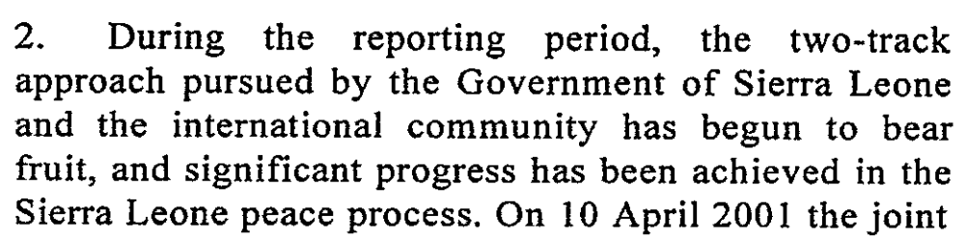
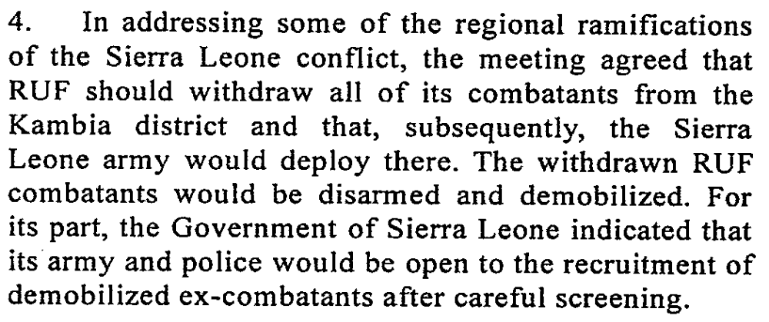
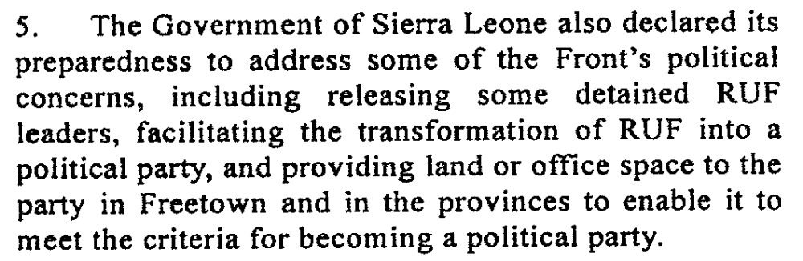

Assessment

Short-term compliance
No or marginal compliance (1) | Medium low compliance (2) | x Medium high compliance (3) | Full or almost full compliance (4)

Considerations underlying the assessment
This demand does not specify each of the “steps” to prepare for the restoration of civil authority. The Government of Sierra Leone clearly made an effort to work with the UN mission to take over certain geographical areas of the country.

Medium-term compliance

Description of the addressee(s)’ conduct
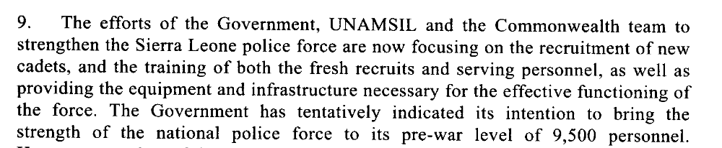
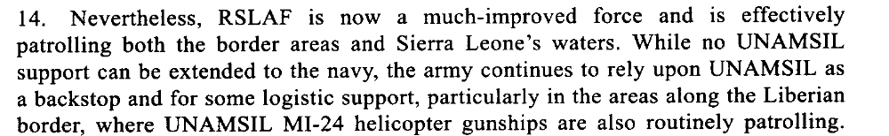
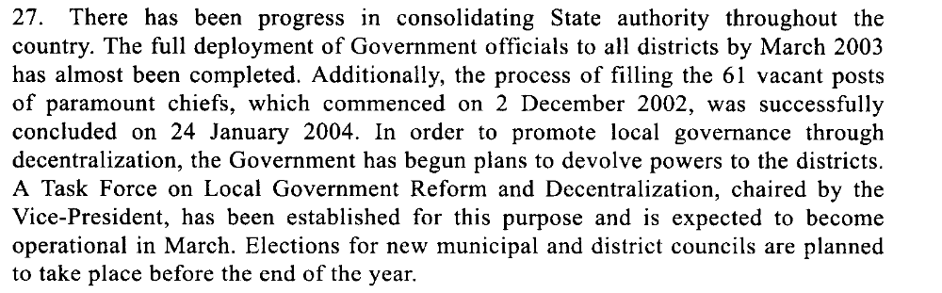17 March 2003

Assessment

Medium-term compliance
No or marginal compliance (1) | Medium low compliance (2) | x Medium high compliance (3) | Full or almost full compliance (4)

Considerations underlying the assessment
There are strong indications that during this period the Government of Sierra Leone made an effort to establish services that would strengthen their authority. In addition they took over duties and territory that had previously been monitored by the UN mission.

Depth of demand

Assessment

Level of depth of demand
Low depth of demand (1) | x Medium depth of demand (2) | High depth of demand (3)

Considerations underlying the assessment
Complying with this demand required the Government to dedicate resources and to strengthen their capacities in various areas, including police, armed forces, and civil authority.

Level of confidence about coding decisions

Level of confidence about coding decision
Extremely high | x High | Moderate

Comments to IPI (if any)

Civil war in Sierra Leone

UNSC Resolution: | 1346
Date of adoption: | 30 March 2001
Operative paragraph: | 14
Demand number: | 1

Megan MacKenzie

Wording of demand

expedite the establishment of the Truth and Reconciliation Commission and the Special Court envisaged by resolution 1315 (2000) of 14 August 2000, bearing in mind in particular the need to ensure the appropriate protection of children

List of addressees of the demand

Government of Sierra Leone

Short-term compliance

Description of the addressee(s)’ conduct

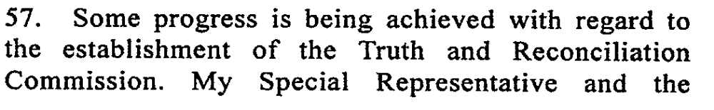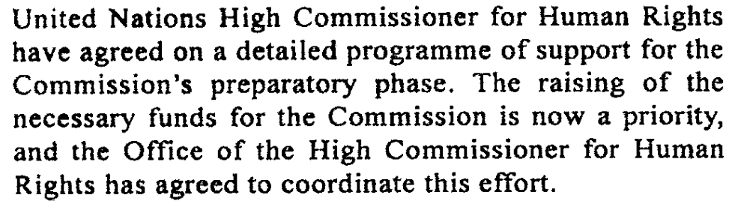
44. UNAMSIL continued to engage the RUF leadership on the issue of the Truth and Reconciliation Commission. A sensitization campaign in the Northern Province was launched at Makeni on 2 August 2001. In general, RUF appears receptive to the Truth and Reconciliation Commission. Nevertheless, they express concern over the independence of the Commission and the relationship between it and the Special Court.
45. On 1 August 2001, the United Nations High Commissioner for Human Rights addressed a letter to potential donors with a preliminary budget and information on the Truth and Reconciliation Commission. According to the initial estimates, the first year of operation of the Commission would cost approximately $10 million. Currently, the Office of the High Commissioner is working with UNAMSIL to revise the preliminary budget prior to the formal
launching of a special appeal by the High Commissioner. The High Commissioner is also
considering the establishment of an interim secretariat for the Truth and Reconciliation Commission, which will initially function under the auspices of UNAMSIL.
In the meantime, the selection process of international commissioners has made progress. The High Commissioner will soon forward her recommendations to the selection panel. Regarding the national commissioners, the Advisory Committee to the Special Representative of the Secretary-General met recently and submitted a shortlist of nominees for his
consideration.

Assessment

Short-term compliance
No or marginal compliance (1) | x Medium low compliance (2) | Medium high compliance (3) | Full or almost full compliance (4)

Considerations underlying the assessment
This resolution specifies that the Government should “expedite the establishment” of the TRC. Although efforts were made towards this objective, it cannot be said that the process was expedient.

Medium-term compliance

Description of the addressee(s)’ conduct

After a troubled start at the end of 2002, the TRC appears to be on a solid footing.92 Statement-takers have collected many statements from both victims and perpetrators. A new executive secretary,Franklyn Kargbo, and much of the permanent secretariat staff were on board by the end of February 2003.93 Public hearings began in Freetown on 14
April, continued throughout the country and concluded on 5 August. A TRC representative expressed confidence that given adequate funds the Commissioners will meet the original deadline of October 2003 for submitting a final report. p11

The TRC’s work has two phases: a three-month preparatory period followed by a twelve-month operational one. The preparatory phase began on 5 July 2002 and, although a number of tasks were not completed, concluded on 4 October. P2

President Kabbah’s government has pledged its moral commitment to the TRC process and, more concretely, has provided U.S.$97,000 in seed money, donated a building for the Secretariat, and made available other facilities in government ministries. p9

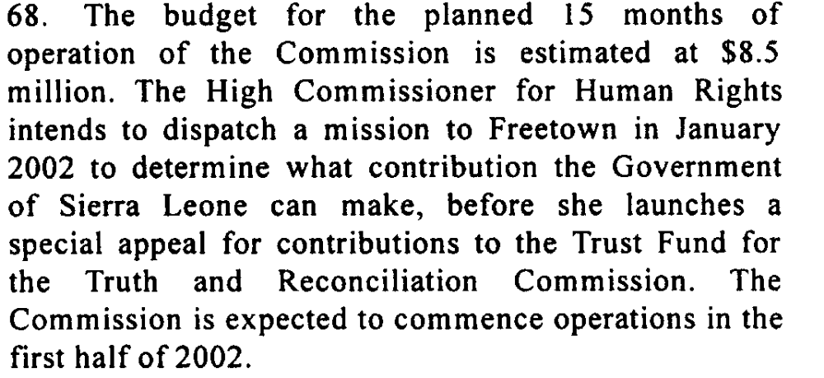

Assessment

Medium-term compliance
No or marginal compliance (1) | Medium low compliance (2) | x Medium high compliance (3) | Full or almost full compliance (4)

Considerations underlying the assessment

This resolution specifies that the Government should “expedite the establishment” of the TRC. The TRC was initiated during this period but there were serious delays, primarily as a result of funding.

Depth of demand

Assessment

Level of depth of demand
x Low depth of demand (1) | Medium depth of demand (2) | High depth of demand (3)

Considerations underlying the assessment

It was in the interests of the Government to establish the TRC as it was seen to promote healing and reconciliation in the country.

Level of confidence about coding decisions

Level of confidence about coding decision
Extremely high | High | x Moderate

Comments to IPI (if any)

ICG SIERRA LEONE: THE STATE OF SECURITY AND GOVERNANCE, ICG Africa Report N°67, Freetown/BrusselsICG Africa Report N°67, 02/09/2003.
USAID p2 http://pdf.usaid.gov/pdf_docs/PDABT690.pdf Sierra Leone: “Conflict Diamonds: Progress Report on Diamond Policy and Development Program, 30/03/2001.
USAID p2 http://pdf.usaid.gov/pdf_docs/PDABT690.pdf Sierra Leone: “Conflict Diamonds: Progress Report on Diamond Policy and Development Program, 30/03/2001.
ICG SIERRA LEONE: THE STATE OF SECURITY AND GOVERNANCE, ICG Africa Report N°67, Freetown/BrusselsICG Africa Report N°67, 02/09/2003.
USAID p2 http://pdf.usaid.gov/pdf_docs/PDABT690.pdf Sierra Leone: “Conflict Diamonds: Progress Report on Diamond Policy and Development Program”30/03/2001.
USAID p2 http://pdf.usaid.gov/pdf_docs/PDABT690.pdf Sierra Leone: “Conflict Diamonds: Progress Report on Diamond Policy and Development Program” 30/03/2001.
ICG SIERRA LEONE: THE STATE OF SECURITY AND GOVERNANCE, ICG Africa Report N°67, Freetown/BrusselsICG Africa Report N°67, 02/09/2003.
ICG SIERRA LEONE: THE STATE OF SECURITY AND GOVERNANCE, ICG Africa Report N°67, Freetown/BrusselsICG Africa Report N°67, 02/09/2003.
Eleventh Report of the Secretary-General on UNAMSIL, (S/2001/857), 07/09/2001.
Eleventh Report of the Secretary-General on UNAMSIL, (S/2001/857), 07/09/2001.
Tenth Report of the Secretary-General on UNAMSIL, (S/2001/627), 25/06/2001.
Eleventh Report of the Secretary-General on UNAMSIL, (S/2001/857), 07/09/2001
SIERRA LEONE: MANAGING UNCERTAINTY, Africa Report N°35, Freetown/Brussels, 24/10/2001.
Eric G. Berman and Melissa T. Labonte, “Sierra Leone” in William J. Durch ed. Sierra Leone 21st Century Peace Operations. (Washington: United States Institute of Peace) p162
Eric G. Berman and Melissa T. Labonte, “Sierra Leone” in William J. Durch ed. Sierra Leone 21st Century Peace Operations. (Washington: United States Institute of Peace) p159
Eric G. Berman and Melissa T. Labonte, “Sierra Leone” in William J. Durch ed. Sierra Leone 21st Century Peace Operations. (Washington: United States Institute of Peace) p187
SIERRA LEONE: MANAGING UNCERTAINTY, Africa Report N°35, Freetown/Brussels, 24/10/2001.
SIERRA LEONE: MANAGING UNCERTAINTY, Africa Report N°35, Freetown/Brussels, 24/10/2001.
Eric G. Berman and Melissa T. Labonte, “Sierra Leone” in William J. Durch ed. Sierra Leone 21st Century Peace Operations. (Washington: United States Institute of Peace) p162
Eric G. Berman and Melissa T. Labonte, “Sierra Leone” in William J. Durch ed. Sierra Leone 21st Century Peace Operations. (Washington: United States Institute of Peace) p161
SIERRA LEONE: TIME FOR A NEW MILITARY AND POLITICAL STRATEGY, ICG Africa Report N° 28, Freetown/London/Brussels, 11/04/2001.
ICG SIERRA LEONE: THE STATE OF SECURITY AND GOVERNANCE, ICG Africa Report N°67, Freetown/BrusselsICG Africa Report N°67, 02/09/2003.
AFRICA Briefing, Freetown/Brussels, 20/12/2002, SIERRA LEONE’S TRUTH AND RECONCILIATION COMMISSION:A FRESH START?
Eric G. Berman and Melissa T. Labonte, “Sierra Leone” in William J. Durch ed. Sierra Leone 21st Century Peace Operations. (Washington: United States Institute of Peace) p162
SIERRA LEONE: MANAGING UNCERTAINTY, Africa Report N.35, Freetown/Brussels, 24/10/2001
Eric G. Berman and Melissa T. Labonte, “Sierra Leone” in William J. Durch ed. Sierra Leone 21st Century Peace Operations. (Washington: United States Institute of Peace) p162
Tenth Report of the Secretary General on UNAMSIL, (S/2001/627), 25/06/2001.
Sixteenth Report of the Secretary-General on UNAMSIL, (S/2002/1417), 24/12/2002.
Seventeenth Report of the Secretary-General on UNAMSIL (s/2003/321), 17/03/2003.
Tenth Report of the Secretary-General on UNAMSIL, (S/2001/627), 25/06/2001.
Eleventh Report of the Secretary-General on UNAMSIL, (S/2001/857) 07/09/2001.
ICG SIERRA LEONE: THE STATE OF SECURITY AND GOVERNANCE, ICG Africa Report N°67, Freetown/BrusselsICG Africa Report N°67, 02/09/2003.
AFRICA Briefing Freetown/Brussels, SIERRA LEONE’S TRUTH AND RECONCILIATION COMMISSION: A FRESH START?, 20/12/2002.
AFRICA Briefing Freetown/Brussels, SIERRA LEONE’S TRUTH AND RECONCILIATION COMMISSION: A FRESH START?, 20/12/2002.
Twelfth Report of the Secretary-General on UNAMSIL, (S/2001/1195), 13/12/2001.

